library(deSolve)

# <https://en.wikipedia.org/wiki/2020_coronavirus_pandemic_in_Germany#Statistics>

Infected <- c(16, 18, 21, 26, 53, 66, 117, 150, 188, 240, 349, 534, 684, 847, 1112, 1460, 1884, 2369, 3062, 3795, 4838, 6012)

Day <- 1:(length(Infected))

N <- 83149300 # population of Germany acc. to Destatis

old <- par(mfrow = c(1, 2))

plot(Day, Infected, type ="b")

plot(Day, Infected, log = "y")

abline(lm(log10(Infected) ~ Day))

title("Total infections COVID-19 Germany", outer = TRUE, line = -2)

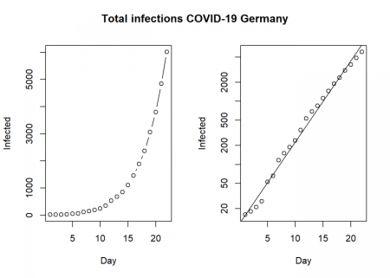

This clearly shows that we have an exponential development here, unfortunately as expected.

SIR <- function(time, state, parameters) {

par <- as.list(c(state, parameters))

with(par, {

dS <- -beta/N * I * S

dI <- beta/N * I * S - gamma * I

dR <- gamma * I

list(c(dS, dI, dR))

})

}

init <- c(S = N-Infected[1], I = Infected[1], R = 0)

RSS <- function(parameters) {

names(parameters) <- c("beta", "gamma")

out <- ode(y = init, times = Day, func = SIR, parms = parameters)

fit <- out[ , 3]

sum((Infected - fit)^2)

}

Opt <- optim(c(0.5, 0.5), RSS, method = "L-BFGS-B", lower = c(0, 0), upper = c(1, 1)) # optimize with some sensible conditions

Opt$message

## [1] "CONVERGENCE: REL_REDUCTION_OF_F <= FACTR*EPSMCH"

Opt_par <- setNames(Opt$par, c("beta", "gamma"))

Opt_par

## beta gamma

## 0.6428120 0.3571881

t <- 1:80 # time in days

fit <- data.frame(ode(y = init, times = t, func = SIR, parms = Opt_par))

col <- 1:3 # colour

matplot(fit$time, fit[ , 2:4], type = "l", xlab = "Day", ylab = "Number of subjects", lwd = 2, lty = 1, col = col)

matplot(fit$time, fit[ , 2:4], type = "l", xlab = "Day", ylab = "Number of subjects", lwd = 2, lty = 1, col = col, log = "y")

## Warning in xy.coords(x, y, xlabel, ylabel, log = log): 1 y value <= 0

## omitted from logarithmic plot

points(Day, Infected)

legend("bottomright", c("Susceptibles", "Infecteds", "Recovereds"), lty = 1, lwd = 2, col = col, inset = 0.05)

title("SIR model Covid-19 Germany", outer = TRUE, line = -2)

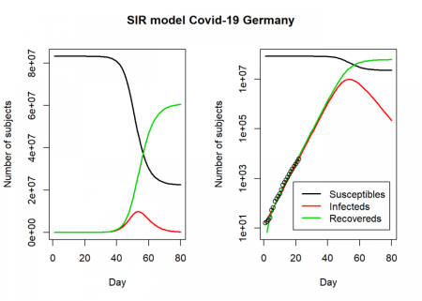

par(old)

R0 <- setNames(Opt_par["beta"] / Opt_par["gamma"], "R0")

R0

## R0

## 1.799646

fit[fit$I == max(fit$I), "I", drop = FALSE] # height of pandemic

## I

## 54 9769398

max_infected <- max(fit$I)

max_infected / 5 # severe cases

## [1] 1953880

max_infected * 0.06 # cases with need for intensive care

## [1] 586163.9

# <https://www.newscientist.com/article/mg24532733-700-why-is-it-so-hard-to-calculate-how-many-people-will-die-from-covid-19/>

max_infected * 0.007 # deaths with supposed 0.7% fatality rate

## [1] 68385.78

So, according to this model, the height of the pandemic will be reached by the end of April, beginning of May. About 10 million people would be infected by then, which translates to about 2 million severe cases, about 600,000 cases in need of intensive care and up to 70,000 deaths.